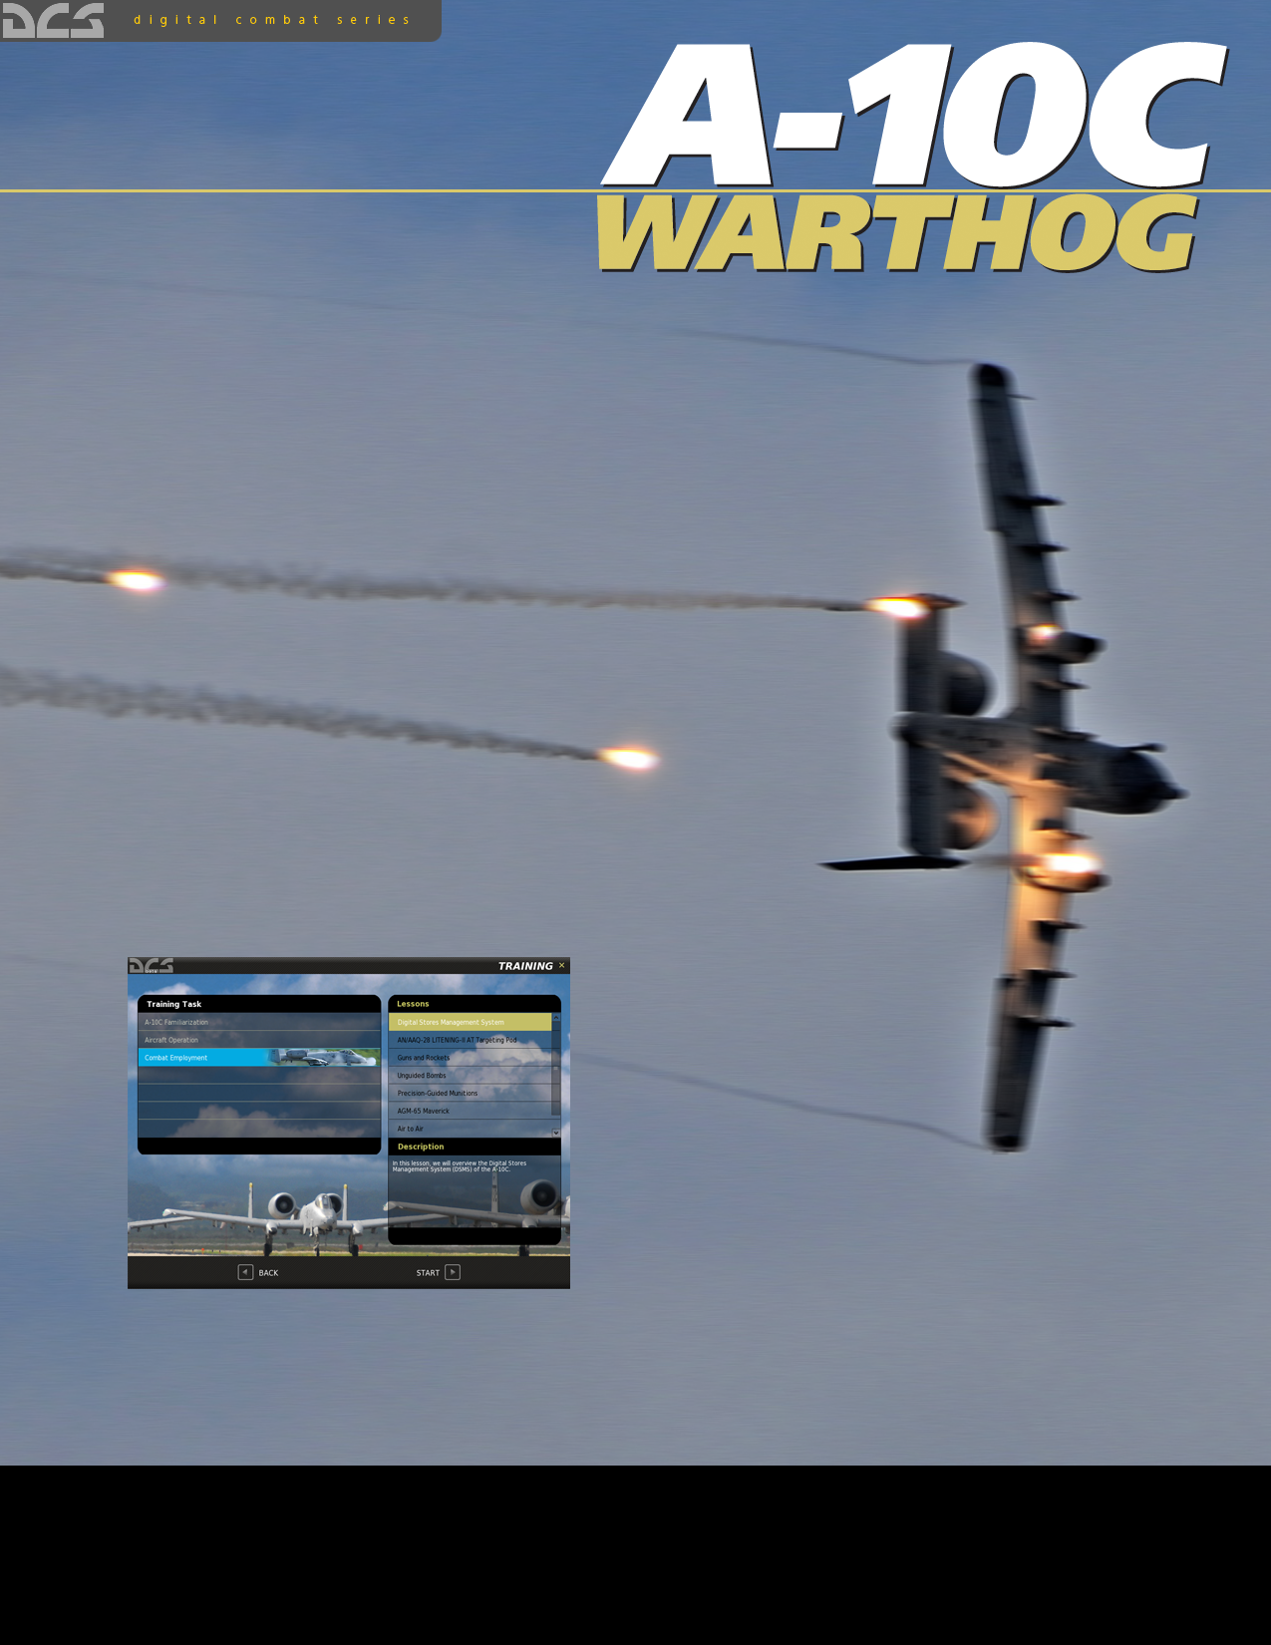
ENTRAINEMENT
ENTRAINEMENT
Afin de vous assister au mieux pendant votre apprentissage du pilotage de l’aéronef, nous avons créé un module d’entrainement qui consiste en une série de missions interactives. Pour entrer dans le menu Entrainement, sélectionnez le bouton Entrainement depuis l’écran du Menu Principal.
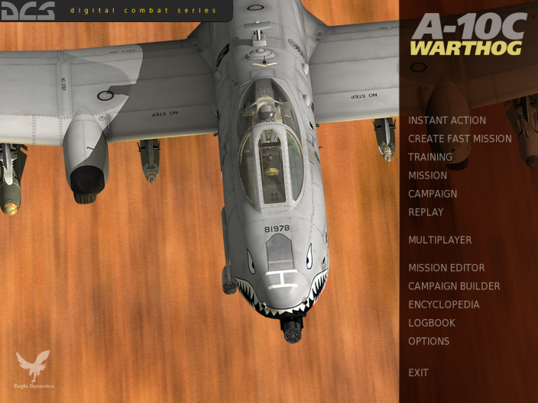
Training

Le menu Entrainement est divisé en trois parties:
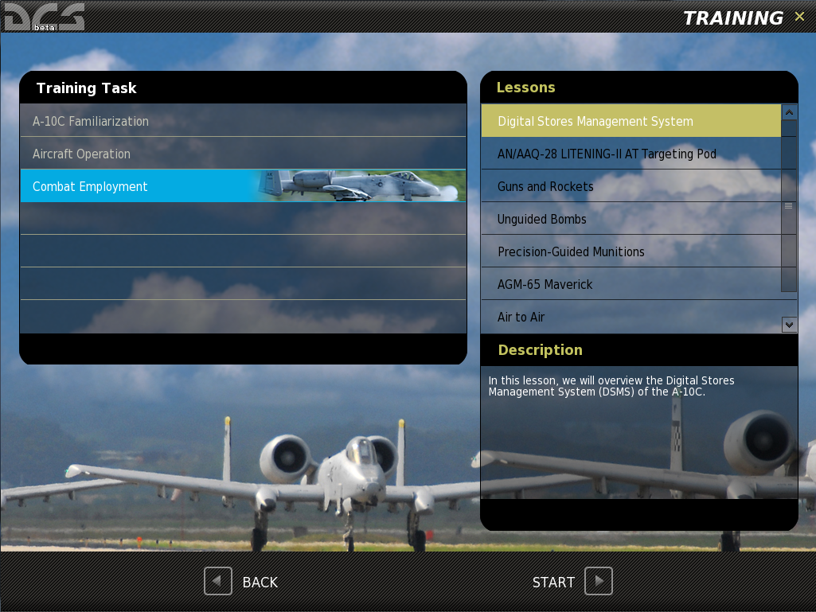
Briefing

Lessons

Training Tasks

- Sujets d’entrainement. L’entrainement est divisé en plusieurs categories de missions, et chaque catégorie est listée dans cette fenêtre.
- Leçons. Après avoir selectionné Sujets d’entrainement par clic gauche, une liste des missions de cette catégorie s’affiche dans cette fenêtre. Chacune de ces leçons est conçue pour vous apprendre un aspect spécifique du Sujet d’entrainement choisie.
- Briefing. Une fois la leçon sélectionnée par un clic gauche, un briefing écrit s’affiche, décrivant la leçon choisie.
En bas de l’écran se trouvent les boutons BACK (Retour), qui retourne vers le Menu principal, et le bouton START (Demarrer) qui démarre la leçon.
Vous pouvez également quitter la page d’Entrainement en cliquant sur le X jaune dans le coin en haut à droite de l’écran.

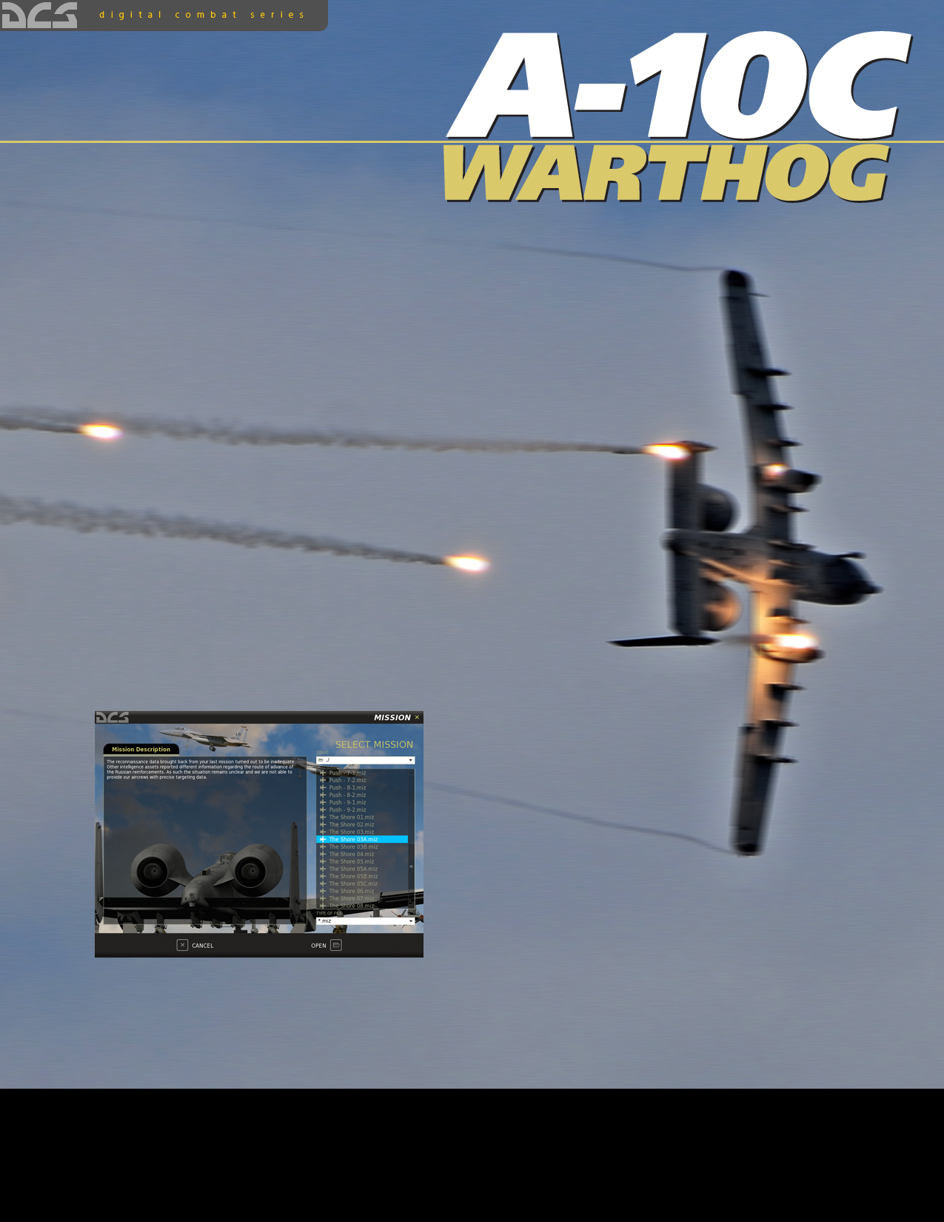
MISSION
MISSION
En utilisant l’éditeur de missions, des missions peuvent être crées pour être ensuite ouvertes et jouées à partir de l’écran de Mission. Pour atteindre l’ecran de Mission, cliquez sur le bouton Mission du Menu Principal.
Mission

Le choix Mission affichera la page Select Mission. Cette fenêtre vous permettra de naviguer sur votre disque local afin de selectionner et chrager une mission sauvegardée. Les missions sont stockées au format .MIZ.
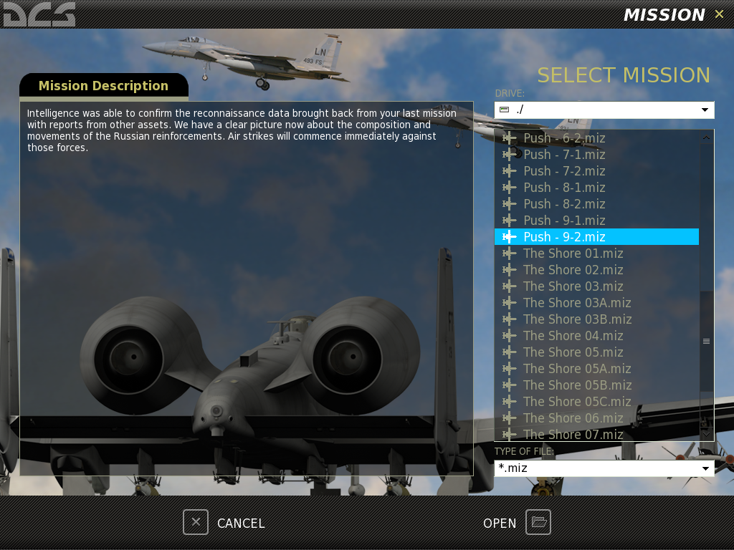
Navigateur

Briefing de mission

En utilisant le fonctionnement standard du navigateur de fichier Windows, vous pouvez selectionnez le lecteur sur lequel vous souhaitez recherché vos fichiers en utilisant le champ DRIVE en haut à droite de la fenetre, pour ensuite selectionner la mission désirée à partir de la liste des dossiers et fichiers.
Once you have selected the desired mission by left mouse button clicking on it, press the OPEN button at the bottom of the window to load it. When the mission is selected, any briefing written for the mission will be displayed in the left side Mission Description window.
You may also exit the window without loading a mission by pressing the CANCEL button at the bottom of the window or the X button in the top right corner.
Having pressed the OPEN button, you will be directed to the Mission Briefing screen. On this screen you are presented with one or more briefing images and the data and mission text briefing.
Mission Briefing Text

Mission Planner Select

Mission Detail Page Select

Mission Details

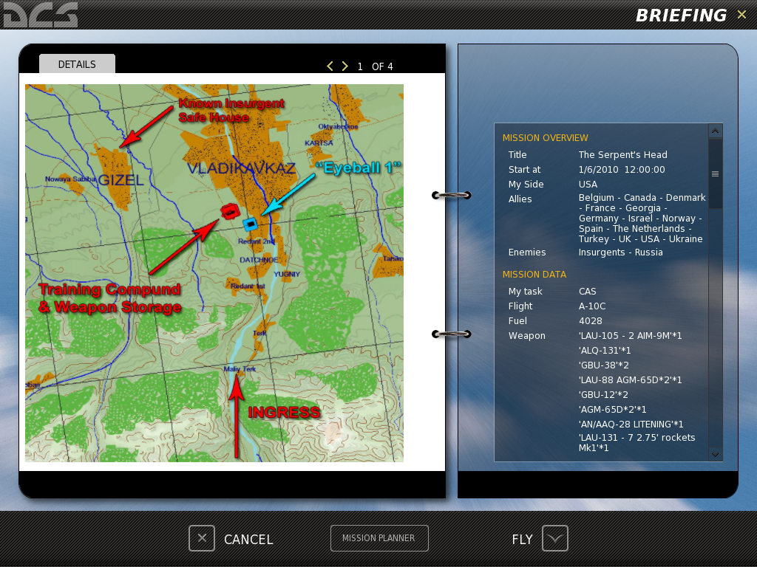
The Mission Briefing screen consists of the following elements:
- Mission Details. Each mission can consist of one or more briefing images. These images are created by the mission designer and can consist of such content as mission maps, target area photo, target vehicle images, etc.
- Mission Detail Page Select. Use the left and right arrow buttons to cycle between Mission Detail briefing images.
- Mission Briefing Text. The scrollable text block on the right side of the screen consists of automatically generated mission data such as sides, flight information, and mission start times. Additionally, a textual briefing can also be included in the Description portion.
At the bottom of the page are three additional buttons.
- CANCEL. Press the cancel button to return to the Mission page. You can also cancel the mission by pressing the yellow X in the top right corner of the page.
- FLY. Press the FLY button to start the mission and enter the simulation.
- MISSION PLANER. Pressing the Mission Planer button will open the selected mission in the Mission Planer and allow you to view it in detail, edit route and weapons of your flight.

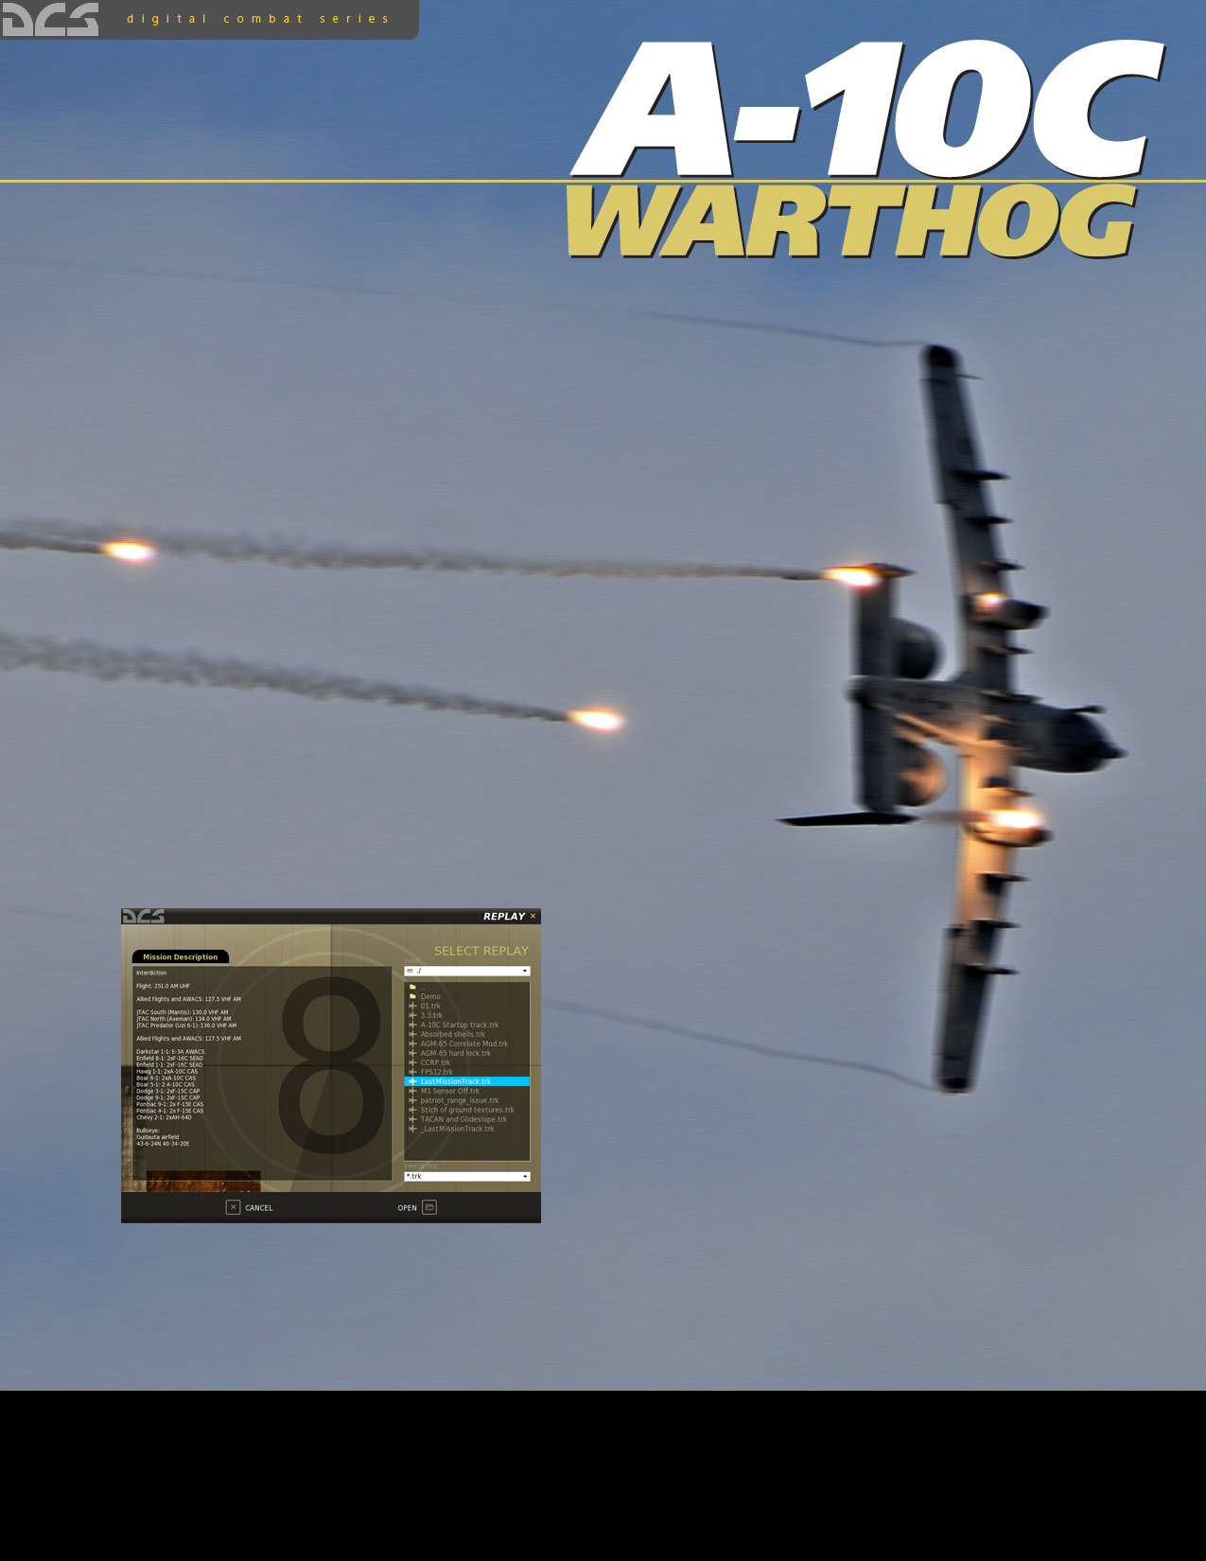
REPLAY
REPLAY
Every time you play a mission, a replay file of the mission is automatically recorded as a .TRK (track) file. When viewing your mission debriefing, you can choose to save the Replay under a different name than the default. However, if you do not and play the same mission again, the original Replay will be overwritten.
To select a Replay file, select Replay from the Main Menu page. Note that you cannot view Replays from the Open mission page or the Mission Editor.

Replay

Upon opening the Replay page, you are presented with a page that is very similar to the Open mission page. This page allows you to browse your local disk(s) and select and load saved Replay files (.TRK).
Using standard Windows file browser functionality, you may select the DRIVE you wish to search using the DRIVE field in the top right of the window and then select the desired Replay from the folder/file listing.
Once you have selected the desired Replay by left mouse button clicking in it, press the OPEN button at the bottom of the window to load it. When the Replay is selected, any briefing written for the mission that the Replay is based on will be displayed in the left side Mission Description window.
You may also exit the window without loading a mission by pressing the CANCEL button at the bottom of the window or the X button in the top right corner.
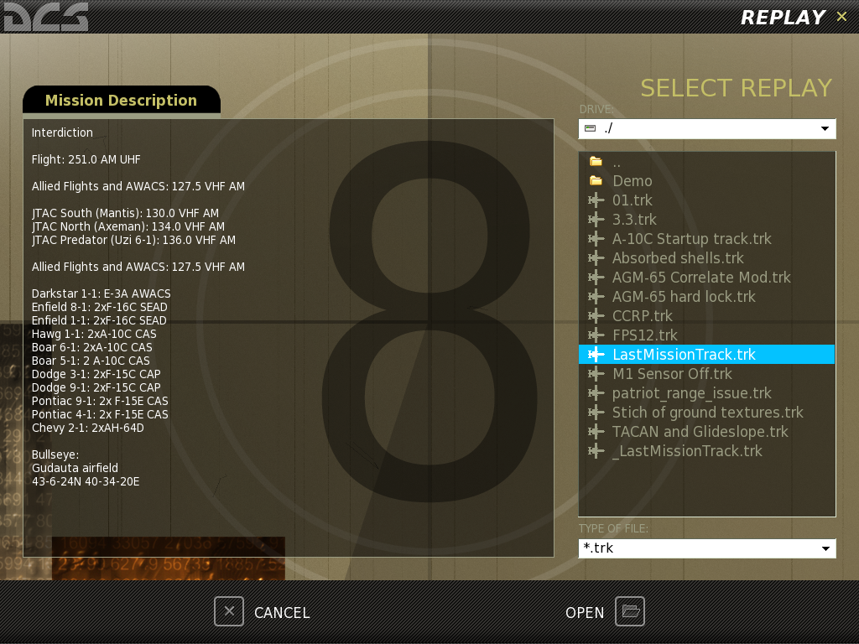
Briefing

Browser

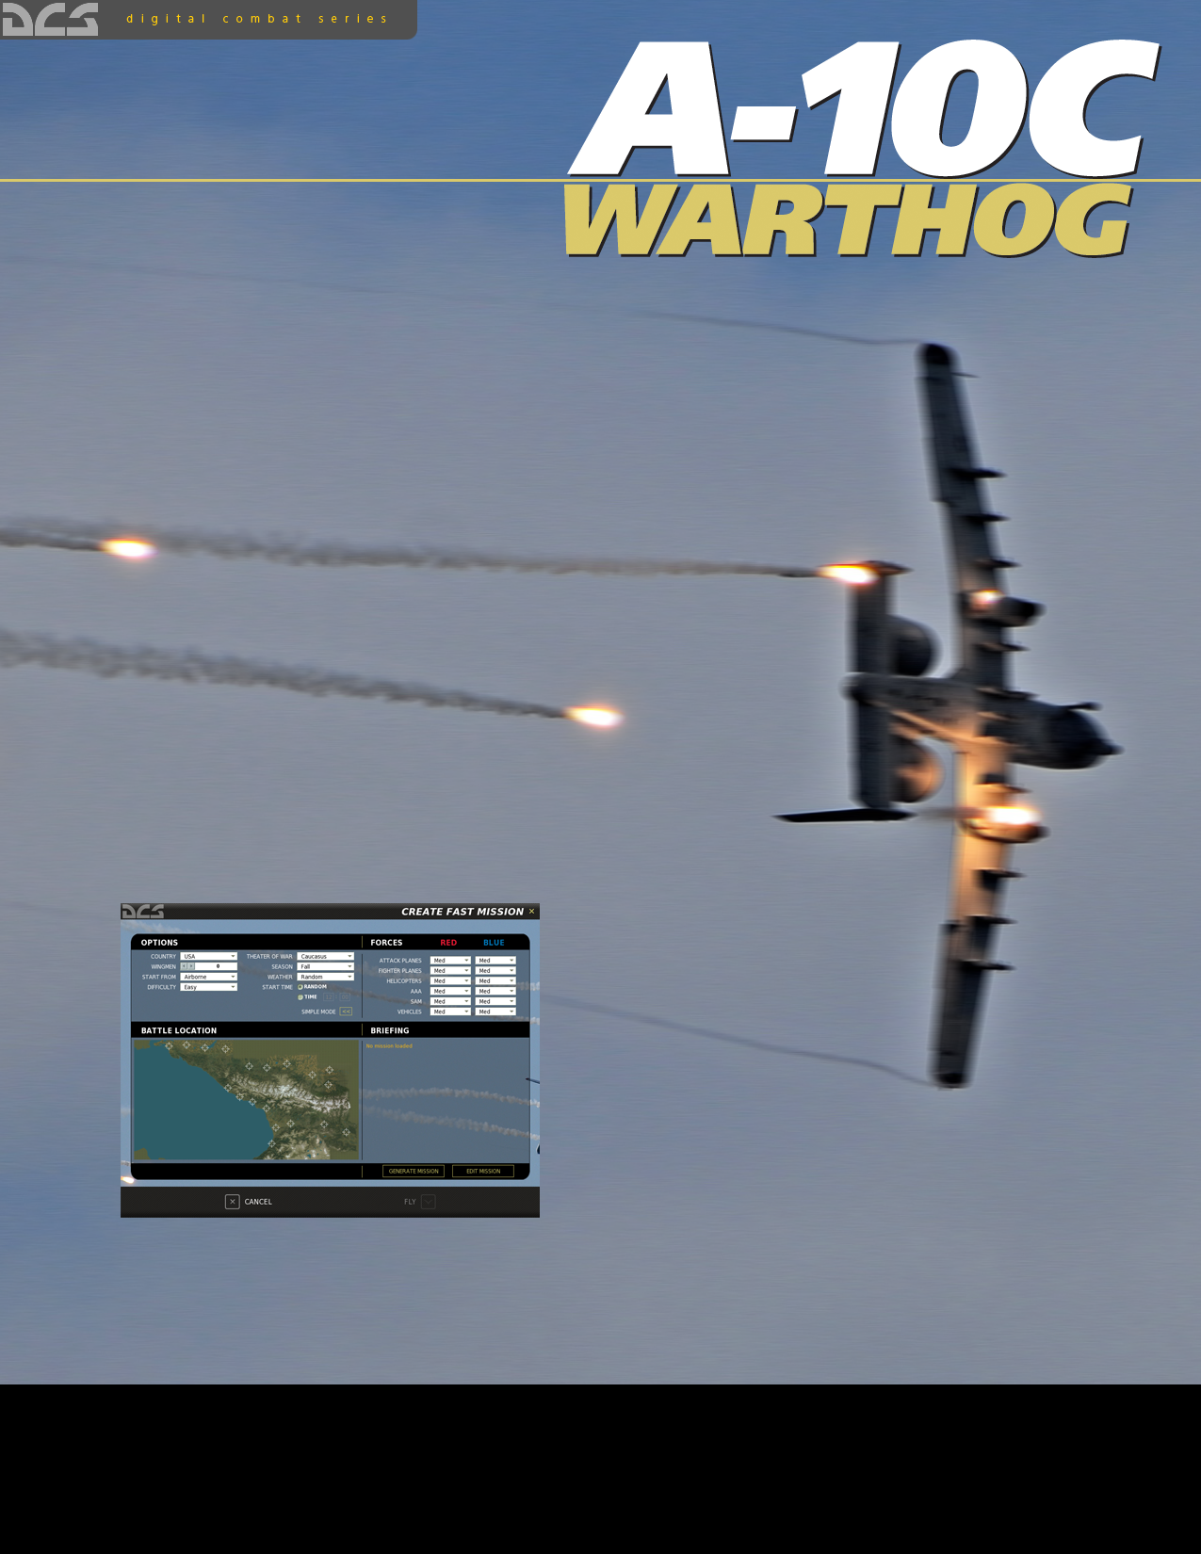
CREATE FAST MISSION

CREATE FAST MISSION
The Create Fast Mission menu allows you to quickly setup mission scenarios to fly. The Create Fast Mission menu is accessed by pressing the Create Fast Mission button on the main menu.
Create Fast Mission

Create Fast Mission has two modes: Simple and Advanced. When first opened from the main menu, Simple mode is selected.
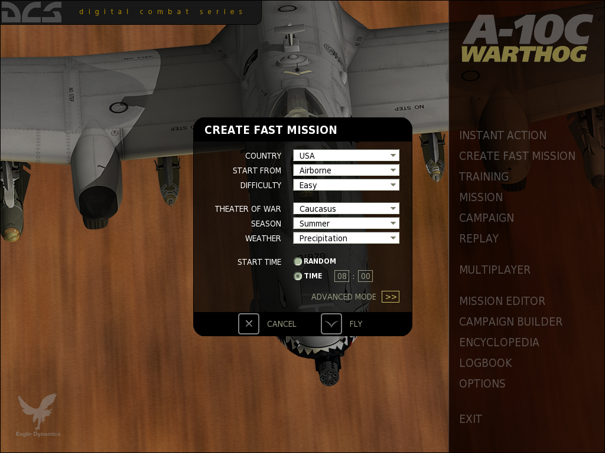

Simple Mode
The Create Fast Mission (Simple mode) panel has the following settings:
COUNTRY. Specifies the country the player will fly for.
START FROM. Specifies where the player will start from.
- Airborne. Player’s aircraft will appear in the air.
- From Runway. Player’s aircraft will be located on the runway closest to the combat area and ready for takeoff.
- From Ramp. Player’s aircraft will be located in the aircraft parking area of the runway closest to the combat area and require a cold start.
- Random. Randomly selects one of the above 3 options.
DIFFICULTY. Specifies mission difficulty level.
- Easy. The mission will contain few enemy units with low skills.
- Medium. The mission will contain average number of enemy units with average skills.
- Hard. The mission will contain high number of enemy units with high skills.
THEATER OF WAR. Specifies the theater of operation.
- Caucasus. The mission will take place in Caucasus region (Russia, Georgia, Abkhazia, South Osetia).
SEASON. Specifies the time of the year.
- Summer.
- Winter.
- Fall.
- Spring.
- Random. Specifies any one of the above seasons.
WEATHER. Specifies the weather in the mission.
START TIME. Mission start time.
- Random.
- Time. Specifies the time in 24-hour format (HH:MM).
ADVANCED MODE. Switches to the Fast Create Mission (Advanced mode) menu.
FLY. Generates the mission and opens to the mission briefing window.
CANCEL. Exits to the main menu.

Advanced Mode
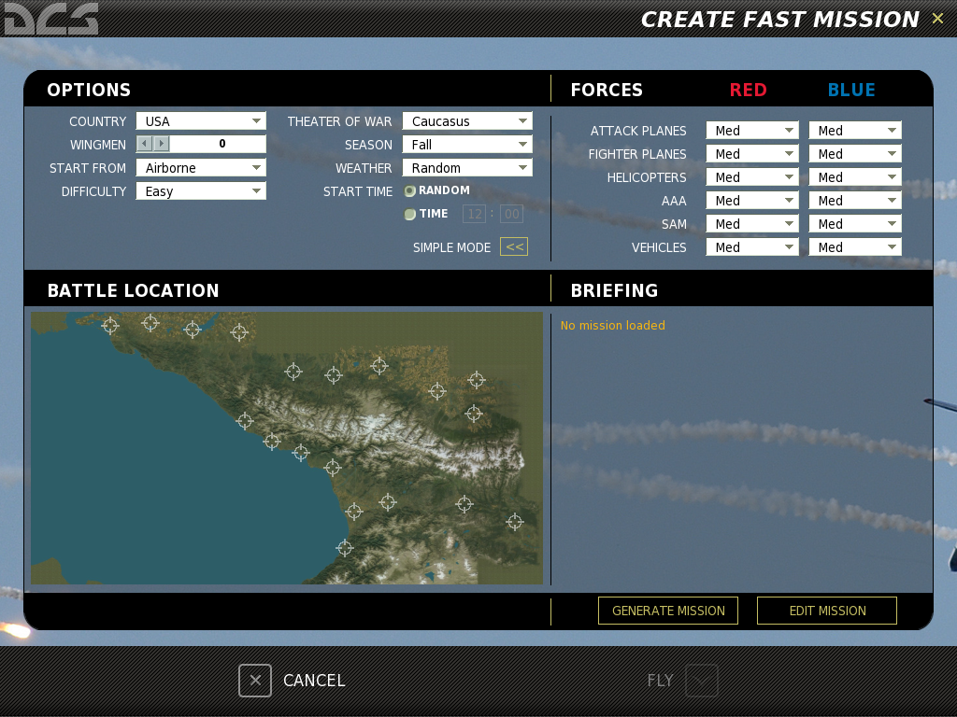
The Fast Create Mission (Advanced mode) menu consists of four main panels: OPTIONS, FORCES, BATTLE LOCATION and BRIEFING.
Options
This section allows you to set all the settings from the Simple Mode described above.
Forces
This section allows you to set force balance between Blue and Red coalitions.
It contains 6 force types and each can have one of 5 balance settings:
- No. The set force type will not be present in the mission.
- Min. Minimum level.
- Med. Medium level.
- Max. Maximum level.
- Random. Random selection among Min, Mid or Max.
The number of units in each category is set according to unit type:
- ATTACK PLANES. Sets the number of attack planes such as Su-25 or A-10.
- FIGHTER PLANES. Sets the number of fighter planes such as Su-27, Mig-29, F-15.
- HELICOPTERS. Sets the number of helicopters such as Ka-50, Mi-24, AH-64.
- AAA. Sets the number of Anti-Aircraft Artillery units such as ZU-23, ZSU-23, Vulcan.
- SAM. Sets the number of SAM units such as M6, Hawk, Stinger, Igla, Osa, Buk, Strela-1.
- VEHICLES. Sets number of vehicles such as tanks, BMP’s, BTR’s, trucks.
The tactical dynamics of combat between Red and Blue forces will depend on the settings in this section.
Battle Location
This panel allows you to choose the general location of combat. To specify the area simply click on it using the mouse.
Briefing
The Briefing windows will display the mission briefing once the mission is generated.
Two buttons are located under the briefing text area:
- GENERATE MISSION. Generates the mission.
- EDIT MISSION. Opens the full mission editor that allows you to fine-tune the generated mission.
Two buttons are located at the bottom of the screen:
- CANCEL. Exits to the main menu.
- FLY. Starts the mission.

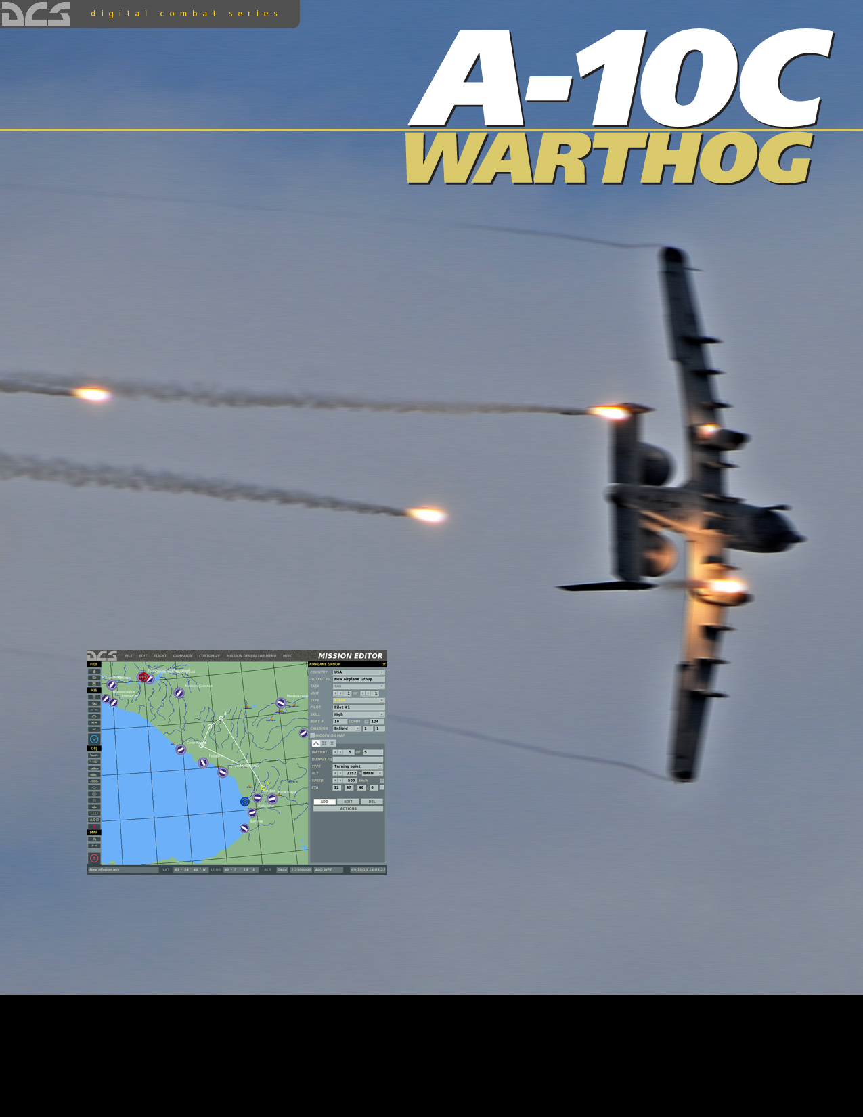
MISSION EDITOR
MISSION EDITOR
The Mission Editor (ME) of allows you to create stand-alone missions, campaign missions, training missions, and multiplayer missions. The ME consists of the following primary elements:
- Interactive mapping system
- Unit placement tools
- Weather editor
- File management system
- Goal creation tool
- Trigger system tool

Starting the Mission Editor
Located on the Main Menu screen is the EDITOR button. Place your mouse over the button and left click. You will then be directed to the ME after a brief loading screen.
Mission Editor

The Mission Editor Map and Navigation
The ME is divided into four primary areas:
- World Map. This area of the screen forms the majority of the screen and displays the topographic map, units, routes, and other mission elements.
- Mission and Map Bar. Along the bottom of the screen is the Mission and Map Bar and this provides you information on cursor location on the World Map as well as mission name and current time.
- System Bar. Along the top of the screen is the System Bar, and from here you control file management, access the campaign editor, the encyclopedia, credits, enable track recording, and duplicate several functions from the Tool Bar.
- Tool Bar. The Tool Bar, along the left side of the screen, provides you a large assortment of tools that allow you to create a mission and modify what is displayed on the World Map.
Each of these areas will be discussed in more detail below.
System Bar

Tool Bar

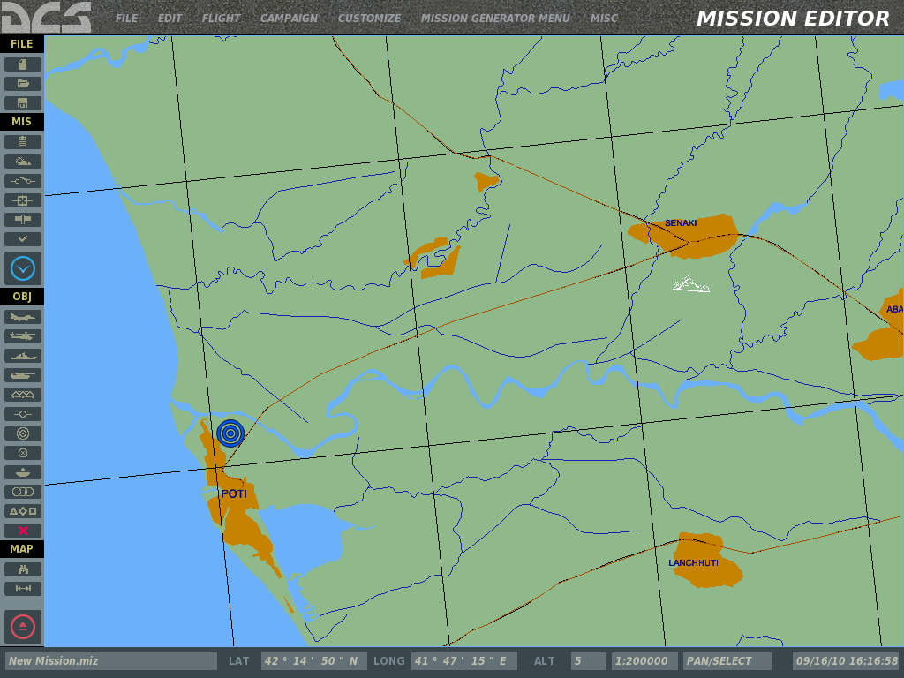
Mission and Map Bar

World Map

The World Map
The World Map consists of the Black Sea region with detailed terrain along the eastern edge. While other areas of the map are represented, they are not as fully detailed as the eastern areas. Using the Options menu (described later), you may filter the data that is displayed on the map such as urban areas, rivers, roads, etc.

Navigating the Map
A right mouse button hold while moving the mouse will pan the view and rotating the mouse wheel controls the zoom level. Selecting an object or unit is done by clicking with the left mouse button. To zoom in on a specific location on the map, place the cursor over the desired location and rotate the mouse wheel forward.
The Mission and Map Bar
Located along the bottom of the screen is the Mission and Map Bar. This is an informative bar that tells you the name of the loaded mission, cursor position and altitude within the World Map, map scale, map mode, and the current time according to your Windows settings (not mission time).
Real Time

Map Scale

Cursor Altitude

Mode

Cursor Coordinate

Mission Name

Note that the coordinates and altitude are controlled according to the position of your mouse on the World Map. These numbers will change dynamically as your move your mouse and correspond to the real life coordinates and altitude of the topography. This can be a useful tool when trying to determine the coordinates of an objective for a mission briefing. Cursor displayed altitude may be set to either feet or meters, depending on your Options/Gameplay/Units setting. The coordinate display can be toggled between Lat/Long, Lat/Long Decimal and MGRS, depending on your Options/Misc/Coordinate Display setting.
With no Tool Bar functions open, the Mode field will default to PAN/SELECT. However, when you select tools such as ADD HELICOPTERS, ADD ZONE, etc., the selected mode will be indicated here. Possible modes include:
- ADD PLANE
- ADD HELI
- ADD SHIP
- ADD VEHICLE
- ADD STATIC
- ADD ZONE
- TAPE
- ADD TEMPLATE
Note that “New Mission” will appear in the Mission Name field until you save a newly created mission.

The System Bar
Located along the top of the screen is the System Bar. The System Bar consists of several pull down menus. These are: FILE, EDIT, FLIGHT, CAMPAIGN, CUSTOMIZE, MISSION GENERATOR and MISC. To select one of these pull down menus, place your mouse over the text and left mouse click.
The System Bar pull down menus provide the following functions:

File
The File functions provide you basic file management of missions. These include:
NEW. Selecting New will allow you to exit the current mission loaded and start a new one from scratch. Before proceeding though, a consent message box is provided to you so that you do not accidentally lose a mission you are working on. After creating a new mission, you will be displayed the THEATER OF WAR and COALITIONS window. This window allows you to define a map and what countries (factions) will be assigned to one of the two sides. Unassigned countries will not take part in the mission. In the left side window all unassigned factions are listed; in the top right window the RED side factions are listed; and in the lower right window all BLUE side factions are listed. To move a faction, left click on the desired faction and then press either the left or right arrow button to move it between the unassigned window and a side window or press the up and down arrows to move the faction to the other side directly.
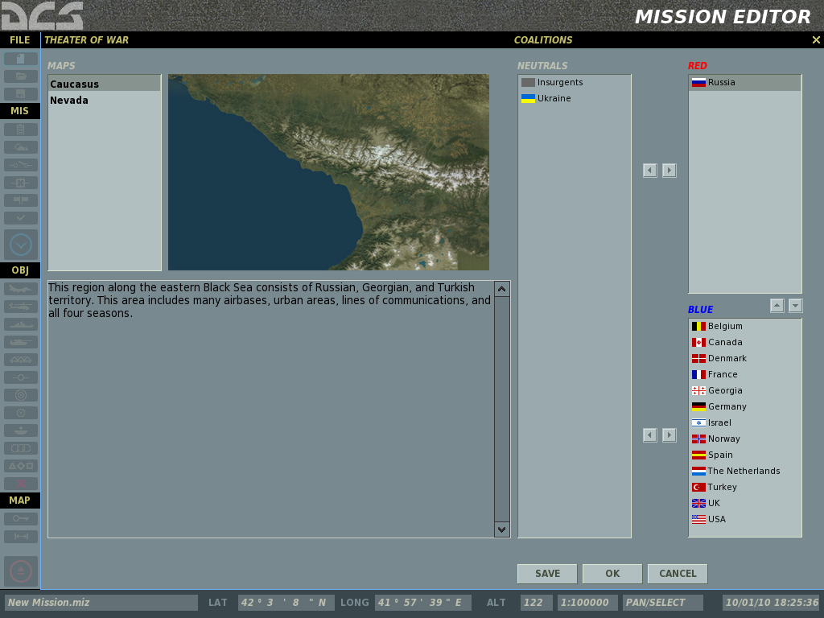
At the bottom of the window are three buttons. The SAVE button allows you to save the current faction distribution and will be set as the default. The OK button will use the current distribution for the mission but will not save it as the default, and the CANCEL button will close the window without applying any changes. You may also close the window by clicking on the X button in the top right corner.
Note: When creating missions, it is up to you to decide who will be allied with whom. You are free to create realistic alliances or make very fanciful ones. We leave it to you to decide.
OPEN. Selecting Open will display the Open Mission window. This window allows you to browse your local disk(s) and select and load saved missions.

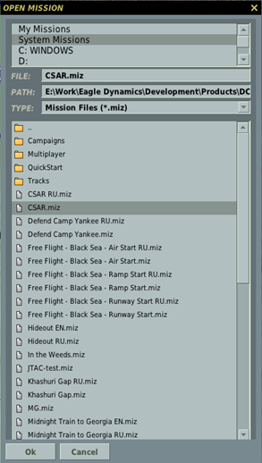
Using standard Windows file browser functionality, you may select the DRIVE you wish to search using the DRIVE field in the top right of the window and then select the desired mission from the folder/file listing. Once you select a mission file, the path to that file is displayed in the PATH field and the name of the mission file is displayed in the FILE field. Note that mission files are assigned a .miz extension.
Once you have selected the desired mission file, press the OK button at the bottom of the window to load it. You may also exit the window without loading a mission or track file by pressing the CANCEL button at the bottom of the window or the X button in the top right corner.
SAVE AS. The Save As function operates much like the Open Mission window but it allows you save a mission file and give it a unique name. The primary difference is that you may overwrite the name in the FILE field as you wish and save the file under that name. To do so, erase the current name and type in the name you wish. You may then use the browser functions to determine where you wish to save the file. Once complete, you must press the OK button to complete the save.

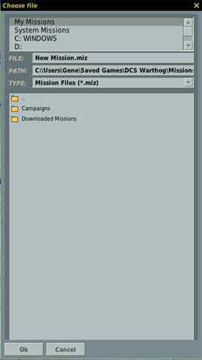
EXIT. Pressing Exit will close the ME and return you to the Main Menu.

Edit
The EDIT pull down provides you a second means of accessing the most important mission construction tools: ADD AIRPLANE, ADD HELICOPTER, ADD SHIP, ADD VEHICLE, ADD STATIC, ADD TEMPLATE, and REMOVE. These tools are duplicated on the Tool Bar and we will discuss them there in detail.

Flight
The Flight menu allows you start a loaded mission to play or start the mission to setup the player's aircraft avionics in PREPARE MISSION mode. This menu also allows you to convert a recorded (track) mission into an AVI video file and access the REPLAY menu for track playback.
FLY MISSION. Selecting this option will close the ME, load the mission into the simulation, and then start the simulation. The loading time of a mission will vary according to the number of units in the mission, the amount of scripting, and how much RAM your computer has.
PREPARE MISSION. The PREPARE MISSION mode is used for integrating navigation and environment data into the saved mission file. When near the end of creating a mission, you can start the mission in the PREPARE MISSION mode (it will look much like usual FLY MISSION start) and configure various avionics in the cockpit. Your avionics settings can then be saved and will start in the saved states whenever other players open the mission.
The following avionics settings can be saved for the A-10C using the PREPARE MISSION function:
- CDU. All adjustments except the flight plan from mission editor.
- IFFCC. TEST menu settings.
- MFCD. Lower line OSB assignments.
- SADL. User ID and other NET adjustments.
- TAD. TAD profiles.
- TGP. Laser code, integration, calibration method, gain settings, TAAF altitude.
- DSMS. Mission Control Page data, weapon profiles.
- Radio manual and preset frequencies.
Once your avionics are setup as desired for the mission, exit the mission and press the SAVE button in the ME once again to save all of the prepared data in the mission file.
NOTE for mission makers:
If you use prepare mission mode, please indicate in the briefing that the player should not use the mission planner. If he'll change the route or weapons for the mission, the avionics scripts saved in the mission file using prepare mission will conflict with the new settings.
If you want to give the player the freedom of action to the use the mission planner, do not use mission prepare mode.
RECORD AVI. This option allows you to convert a Track file (which can only be viewed in the game) to an AVI video file that can be viewed by anyone using video playback software.
Once a Track file has been created, you may load the file into this tool and then set the video quality of the AVI video output. A few notes:
- Because the AVI tools render the Track file frame by frame and NOT in real-time, you can create an AVI with higher or lower frame rates than when the track was originally recorded.
- The higher the video quality and longer the recording, the longer it will take to render the AVI. Setting the FPS slider too high will also lengthen the time it takes. Please note that rendering long, high-quality AVIs can be a very time consuming process.
- Once the AVI is created, you may then play it back outside of the game or convert and compress it with other codecs.
- Using the START and FINISH fields, you can create an AVI out of just one part of a larger Track file.
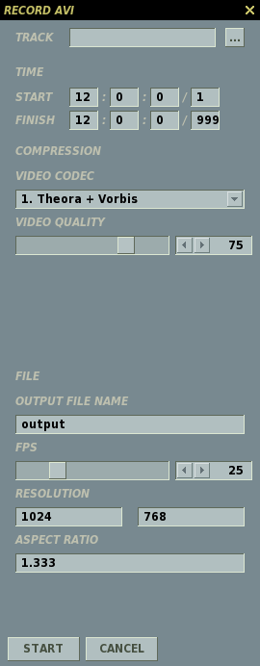
AVI Aspect Ratio

Video quality

Video and Audio Codecs to Use

Record Start and End Time

Track Select

AVI File Name

Frame Rate Play Back

AVI Resolution

Campaign Editor
The Campaign Editor is what we term a Staged Campaign System (SCS). We will describe the functionality of the Campaign Editor in detail in the Campaign Editor chapter.

Customize
The Customize menu allows you to configure a number of map display options and set gameplay options for the mission.
Mission Options
The Mission Options menu can be used to lock certain gameplay options for the particular mission loaded. When the "USE THESE OPTIONS FOR ALL MISSIONS" check-box is unchecked in the Options\Gameplay menu, the locked mission options will override the settings in the main Options. However, when the "USE THESE OPTIONS FOR ALL MISSIONS" check-box is checked, the settings in the main Options screen will take priority.
Along the left side of the window are the ENFORCE buttons. Checking an ENFORCE button will force the settings of this option on the player of the mission.
Along the right side of the window are the VALUE buttons. VALUE buttons operate as on/off variables. When checked, the options will be forced ON. When unchecked, the option will be forced OFF.
From the left side of the Mission Options window, you may select the following mission options to enforce:
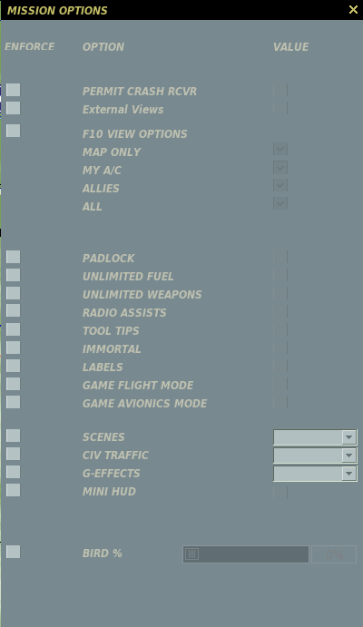
PERMIT CRASH RCVR. If your aircraft is destroyed during a mission or you eject, you may respawn in an undamaged aircraft.
EXTERNAL VIEWS. When Enabled, external views are allowed.
F10 VIEW OPTIONS. When enabled, you may select one of the mutually exclusive radio buttons:
- MAP ONLY. Map only view. No aircraft, vehicles or ships are displayed.
- MY A/C. Only your aircraft.
- ALLIES. Only your aircraft and allied units.
- ALL. All units from both sides are displayed.
PADLOCK. When enabled, you press the padlock enable key to keep your eyes on the vehicle or ground point in the center of your view.
UNLIMITED FUEL. When enabled, fuel will not deplete from your aircraft. Note that you will always have 100% fuel when this is selected.
UNLIMITED WEAPONS. When enabled, expended weapons will automatically be replenished.
RADIO ASSIST. When enabled, you are provided voice cues regarding approaching threats, when you fall within valid weapon launch parameters, and launch warnings.
TOOL TIPS. When enabled and when you hover your mouse over a control in the cockpit (button, switch, dial, or lever), you will be shown a brief tool tip of the function of the control.
IMMORTAL. When enabled your aircraft cannot be destroyed or even damaged.
LABELS. When enabled, you can display easy-to-spot labels about friendly and enemy units. Close units will display the unit type name and the range from you. Units at medium range will only show the range to unit. Units at long range will only be marked with a tic-mark.
GAME FLIGHT MODE. Easy flight makes the aircraft much easier to fly when enabled and more analogous to an arcade game.
GAME AVIONICS MODE. This option allows simple targeting, an all-seeing sensor, and additional threat warnings. For a detailed explanation of Easy Avionics mode, please consult the Options/Gameplay portion of this manual.
SCENES. When enabled, there are three levels of scenes you can choose from. Scenes consist of the object population on the map which consists of buildings, trees, power lines, etc. Your scene setting can have a big impact on how smooth your gamepaly is. If you have choppy gameplay, you may wish to lower this setting. Possible settings include LOW, MEDIUM, and HIGH.
CIV TRAFFIC. When enabled, the world can be populated by moving cars, trucks and trains throughout the detailed world area. If enabled, possible settings include OFF, LOW, MEDIUM, and HIGH.
G-EFFECT. When enabled, you may select the level of G-effect. Possible settings include: NONE, GAME, and SIMULATION.
BIRDS. This adjust the probability of a bird strikes when flying at altitude below 200 meters. 100% is the realistic bird strike probability setting. 0% - no birds. 1000% - the bird strike probability multiplier 10 times.
Map Options
The Map Options selection from Customization allows you to filter the information that is displayed on the World Map as layers.

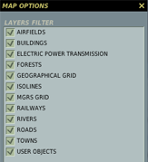
Filter Layer List

The majority of this window consists of the map filter window. Each item on the list has a check box, that when checked, displays the map data on the ME World Map. Filter items include:
- AIRFIELDS. Airport icons that orient in the correct runway direction.
- BUILDINGS. Individual buildings that are visible at low scales. This is OFF by default.
- ELECTRIC POWER TRANSMISSION. High tension power line towers and cables.
- FORESTS. Large stands of trees. Note the trees in and around urban areas are not indicated.
- GEOGRAPHICAL GRID. Latitude and longitude lines.
- ISOLINES. Continuous lines around terrain relief to indicate elevation change.
- MGRS GRID. Display MGRS coordinate grid over the map.
- RAILWAYS. Display the railway system.
- RIVERS. Small rivers and streams.
- ROADS. Small and major road network.
- TOWNS. Urban areas are indicated as orange shaded areas and when at small map scales, individual buildings are indicated.
- USER OBJECTS. Any objects placed on the map by the user.
Airport Icons
Helipad. The temporary place of deployment of Army aviation.
Field airdrome (not present in game)
General aviation airfield (not present in game)
Third class airdrome. 1200…1700 meters runway (not present in game)
Second class airdrome. 1800…2400 meter runway.
First class airdrome. 2500…3000 meter runway.
To close the window, click the X button in the top right corner of the window.

Mission Generator
The Mission Generator selection opens the Mission Generator menu. The Mission Generator is a powerful tool, which can be used to create battle scenarios throughout the entire map. The Mission Generator creates missions for the Create Fast Mission application. Using the Mission Generator menu of the mission editor, you can edit or create new possible mission generation options for Create Fast Mission. The Mission Generator pull-down menu includes the following four items: GENERATE, NODES, TEMPLATES, and SAVE.
- GENERATE. Opens the Fast Create Mission (Advanced Mode) menu to generate a mission.
- NODES. Opens the Mission Nodes panel and displays all default node templates on the map. This menu can be used to create new nodes or edit/remove default ones. Nodes define where blue and red forces can be spawned on the map.
- TEMPLATES. Opens the Templates Editor panel. This menu can be used to create new templates or edit/remove default ones. Templates are used to edit the unit types, numbers, and formations used when populating nodes.
- SAVE. Clicking SAVE will save the settings of all nodes and templates.

Misc
The Misc customization consists of two items: the Encyclopedia which is described further in this manual, and the game credits.

